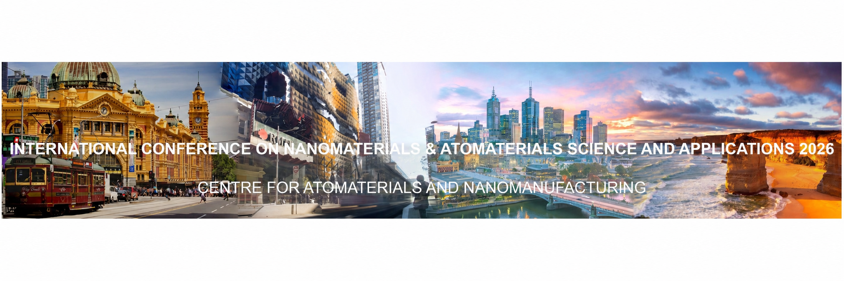
Formal Invitation Letter for attending ICNASA
23-26 Nov 2026, Melbourne, Australia
Dear XXX,
The International Conference on Nanomaterials & Atomaterials Science and Applications (ICNASA 2026; https://www.icnasac.com/) will be held at RMIT University in Melbourne, Australia, from 23–26 November 2026. Hosted by the Centre for Atomaterials and Nanomanufacturing (CAN), the conference will showcase the latest advances in micro-, nano- and atomic-scale materials, catalysis, energy conversion and storage, optoelectronics, devices, therapeutics and diagnostics. Particular emphasis will be placed on emerging concepts and methods in materials modelling, synthesis, fabrication, characterisation, device development, manufacturing and translation.
ICNASA provides an international forum for researchers, industry leaders, policymakers and innovators to exchange knowledge and establish collaborations across materials science, engineering, advanced manufacturing and industrialisation. A major feature of ICNASA 2026 will be the Industry Forum, which will bring together representatives from academia, industry, investment and government to discuss research translation, technology scale-up, commercialisation, industry challenges and opportunities for collaborative innovation.
In recognition of your outstanding contributions to [field/topic], on behalf of the Organising Committee, we would be delighted to invite you to attend ICNASA 2026 and present your latest research findings. We believe that your participation would make a valuable contribution to the scientific program and to the overall success of the conference.
We hope this invitation letter will assist you with any visa arrangements required for your visit to Australia. We look forward to welcoming you to Melbourne. Please feel free to contact us should you require any further information.
Yours sincerely,

Baohua Jia | Distinguished Professor | FTSE | ARC Future Fellow | Director
Tianyi Ma | Distinguished Professor | FRSC | ARC Future Fellow

Conference Chair On behalf of Organising Committee, International Conference on Nanomaterials & Atomaterials Science and Applications (ICNASA)

Centre for Atomaterials and Nanomanufacturing (CAN)
School of Science | STEM College | RMIT University
Email: baohua.jia@rmit.edu.au, tianyi.ma@rmit.edu.au
Address: RMIT University, City Campus, Building 003, 124 La Trobe Street, Melbourne, VIC 3000, Australia
Webpage: www.icnasac.com

